**Assignment – 8**

1. **Create new Project**

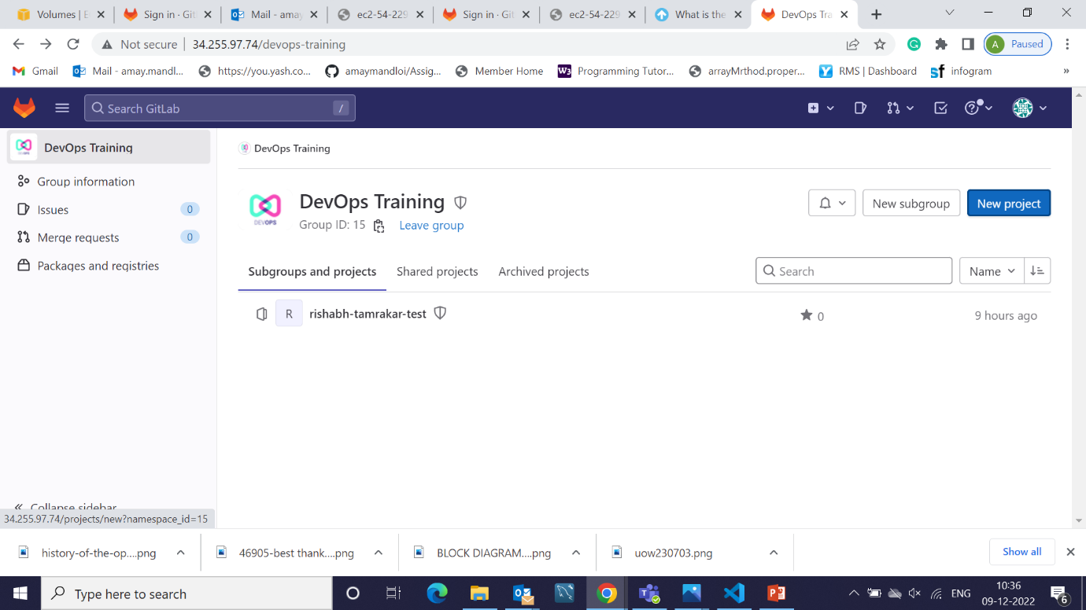

1. Select Create from Templete

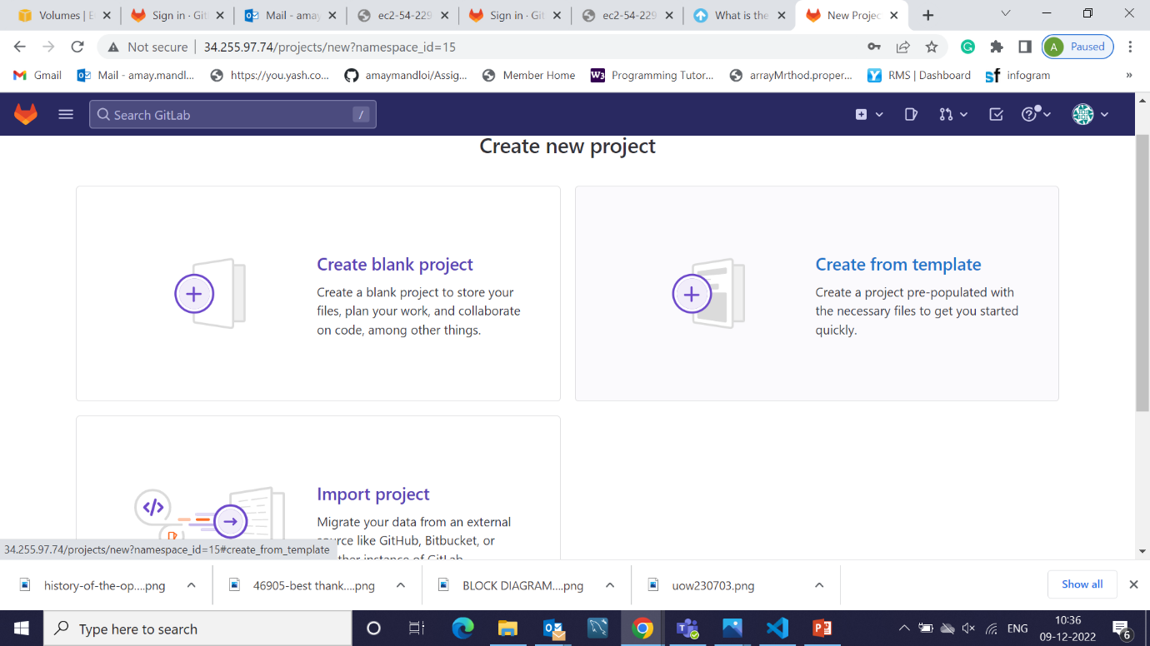

1. Use Template Sample GitLab Project

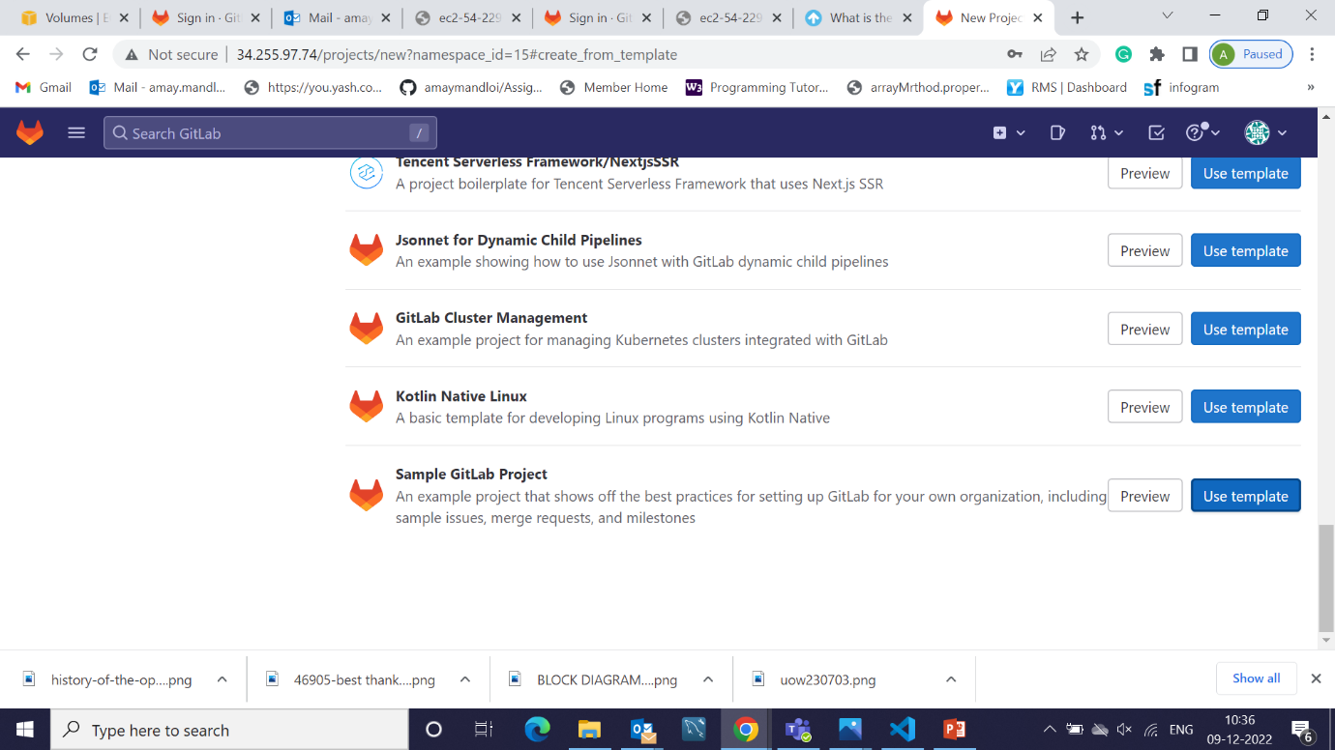

1. Write Project Name

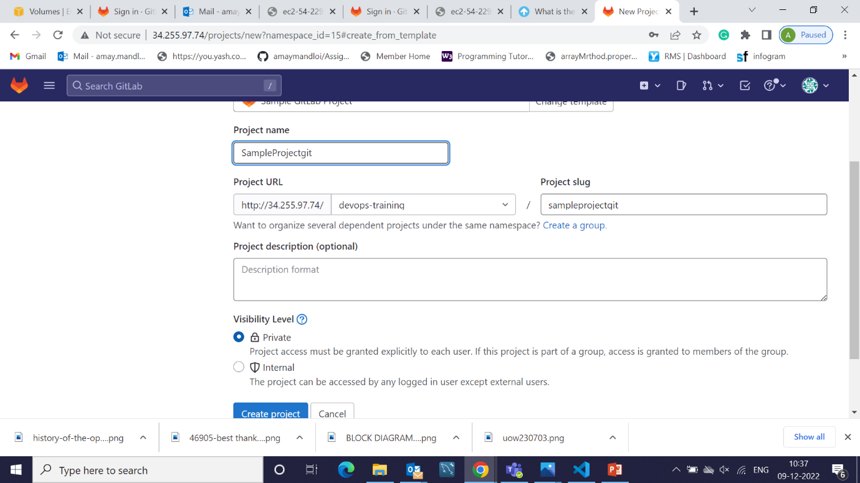

1. Project Created

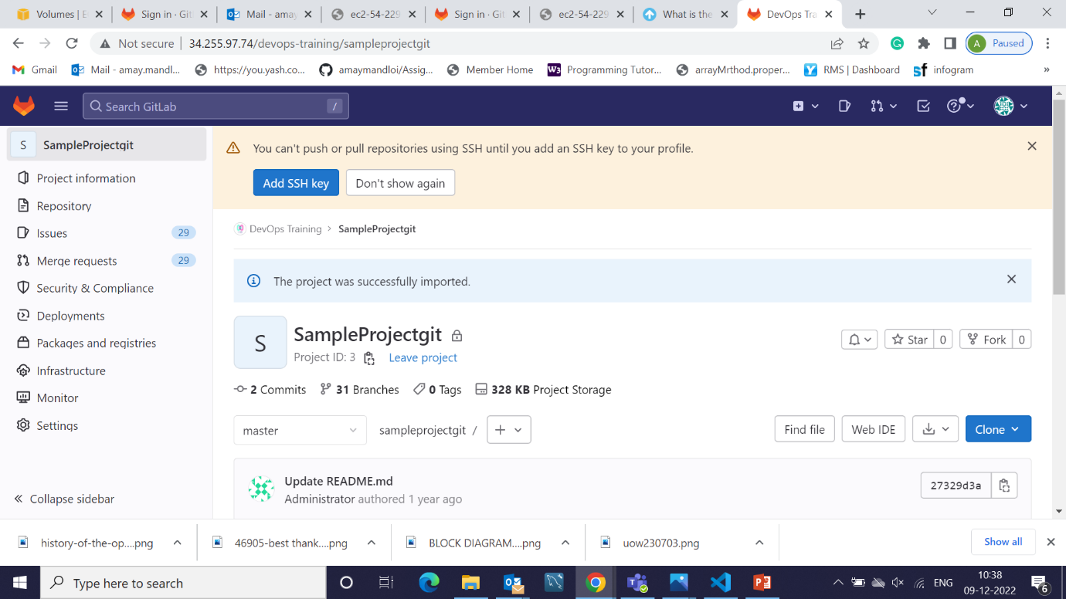

1. Going to Setting select general setting

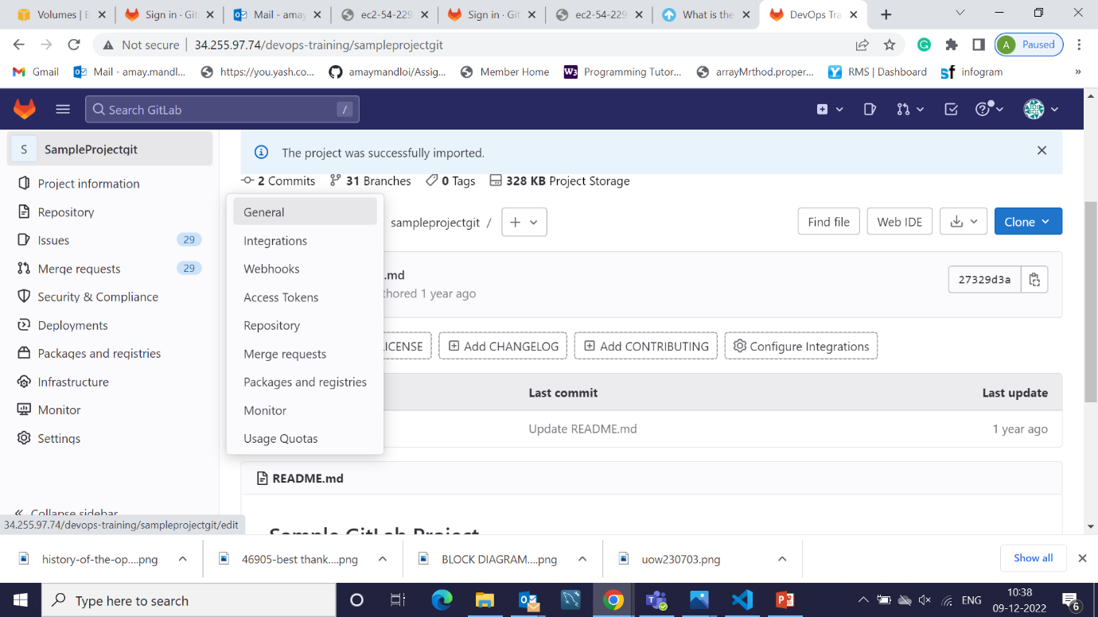

1. Expand Visibility Project features

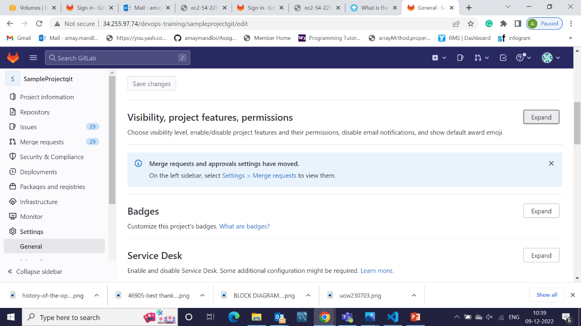

1. Enable CI/CD Features and Save changes

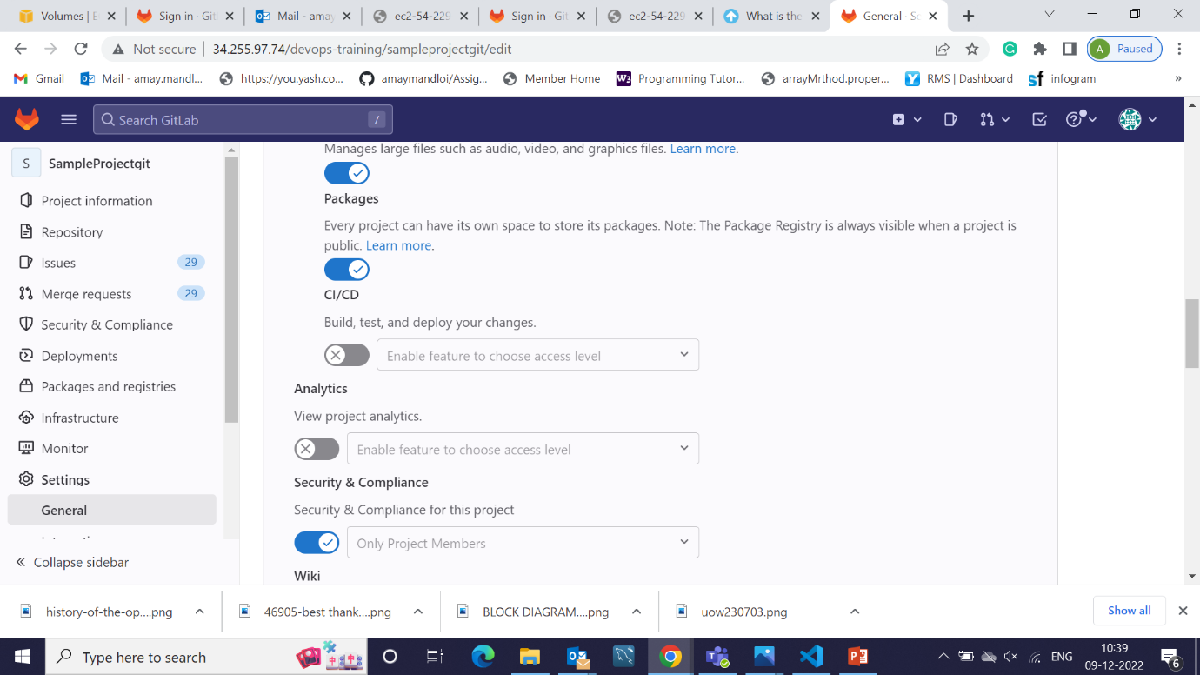

1. Create a Bucket in AWS S3

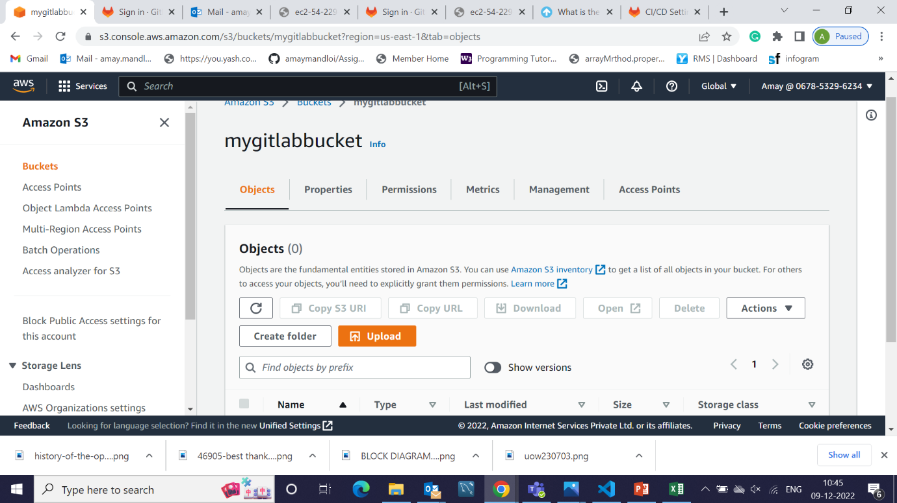

1. In Gitlab, Create Variable for S3

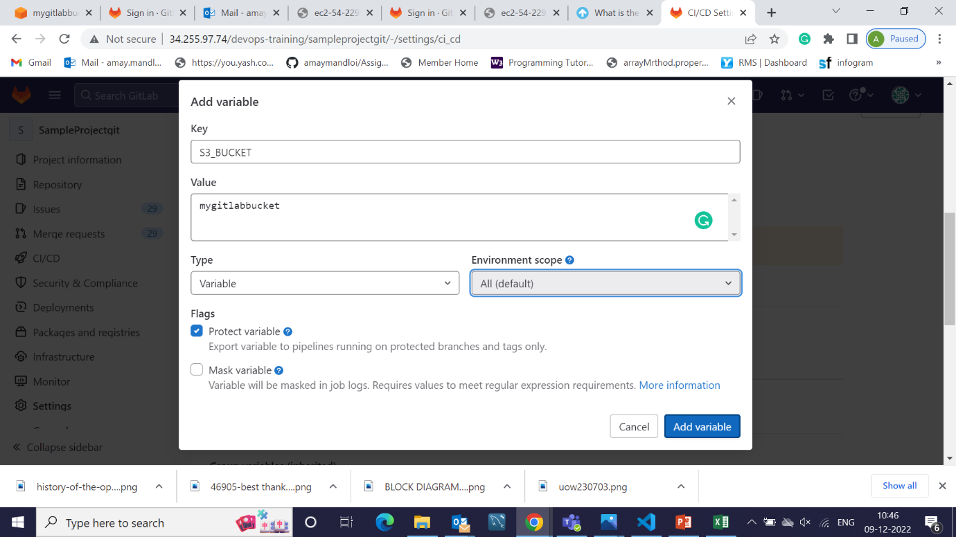

1. Add Variable for User Key Id

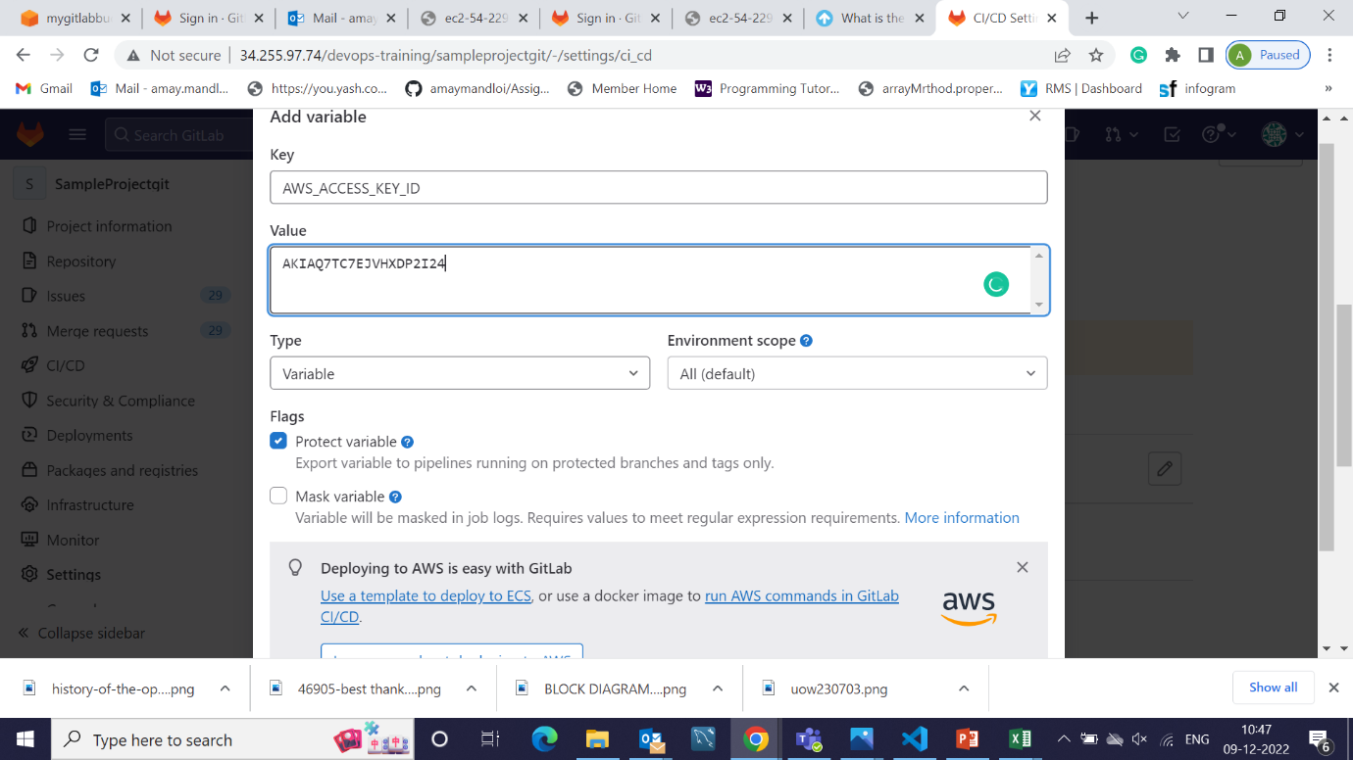

1. Add Variable For User Secret Key

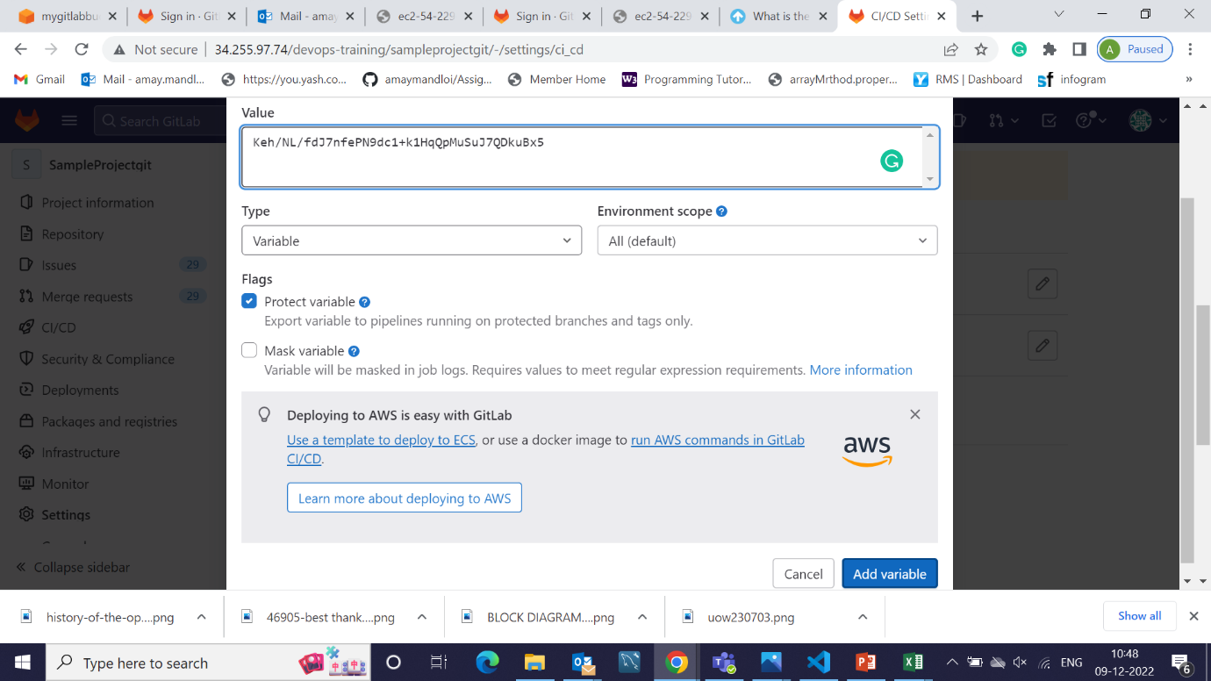

1. Three Variable

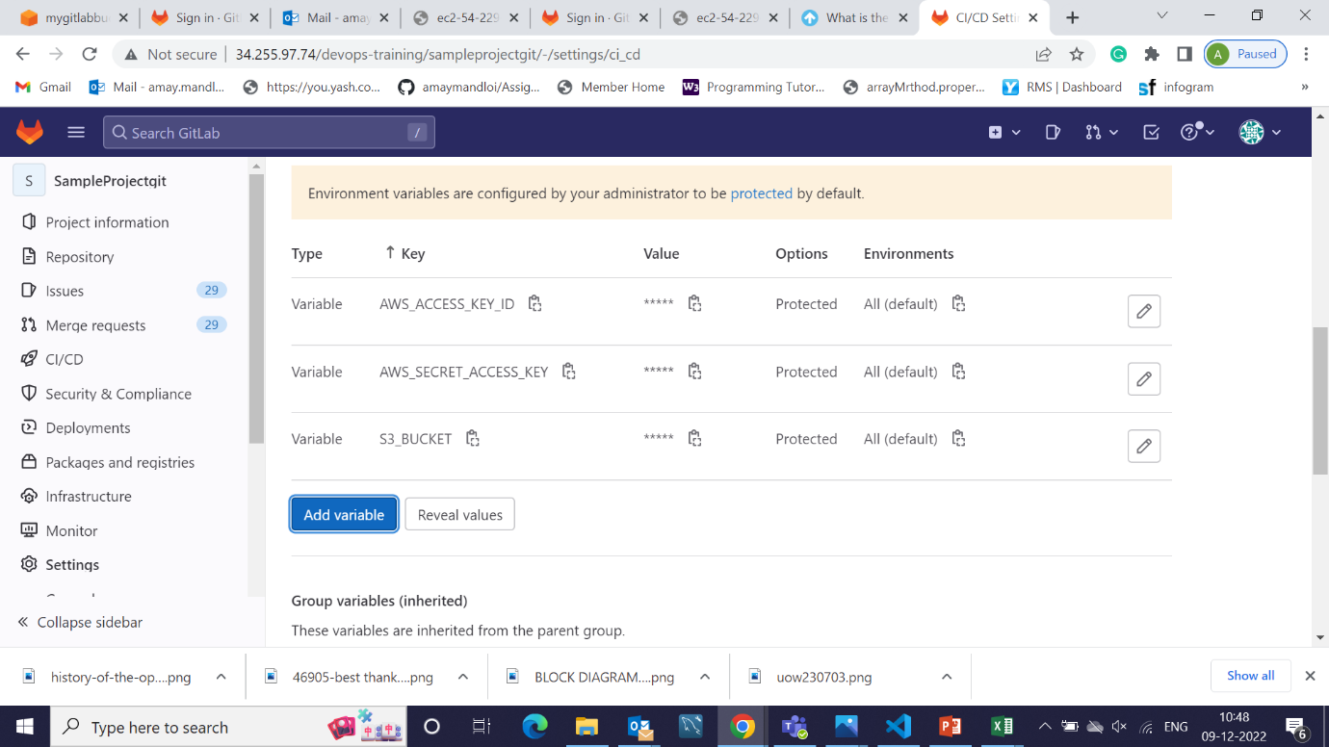

1. Gitlab Configuration for pipeline

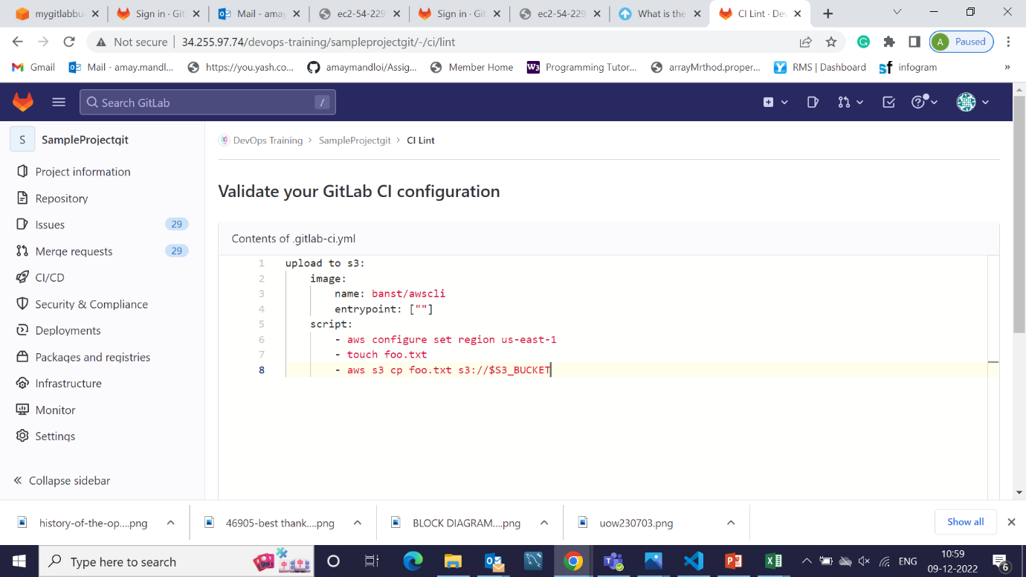

1. Validate Gitlab Configuration

